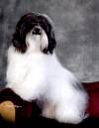 | GCH UKC BIS Beseme's Dancing With The Stars and  BCH CH Beseme's Telling It Like It Is -  5 generation pedigree (100% complete) | 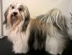
LGD=81.25% (32/26)
COI = 28.13%
Hide details
CH Los Feliz Splash Of Mollimar: 12.5%
GCH CH Beseme's An Affair To Remember: 9.375%
Destiny's Shelley's Cookies N Creme: 3.125%
CH Alderon's Shelley's Jamoacha: 3.125%
AKC GCH UKC BISBeseme's Dancing With The Stars | CHLos Feliz Splash Of Mollimar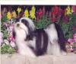 | CHLos Perritos Wee PantaloonsROMX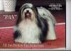 | CHLos Perritos LuigiROM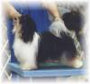 | AM CHKatrina's Charmer Of ManfredROMX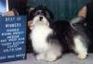
 |  |  |  | HCA, CKC, ARBA, RARITY, DFUSA, INT IABKCA CHTi-Ara's Patty CakeROM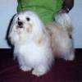
 |  |  | US CHBorgia's Evita Of Romanijo's JoyROMX | A Maiden Effort's Jazz-Up
 |  |  |  | NLCHA Maiden Effort's Ice Sugar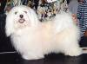
 |  | CHKolmar's MS QT PI Of Los Feliz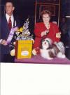 | AM. CAN. CH.Voila Clean SweepROM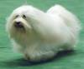 | INTUCH NORDUCHVoila Wow That's ItSV-99,NORDV-99,FINV-00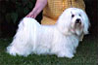
 |  |  |  | Voila Leading Lady
 |  |  | CHKolmar's La Nina Del Milenio | CHStarkette Pride of WincroftROMX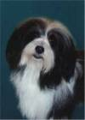
 |  |  |  | CHKolmar's Starkette Las Palma
 | GCH CHBeseme's An Affair To Remember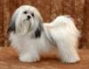 | CHShelley's Rickie Ricardo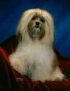 | CHAlderon's Shelley's Jamoacha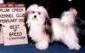 | CHLos Perritos Make It Happen
 |  |  |  | Alderons Sparkling Chablis
 |  |  | Destiny's Shelley's Cookies N Creme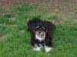 | Kimbriel's The Cisco Kid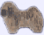
 |  |  |  | Grillo De Destiny
 |  | CHLiveoak's Southern CharmRN ROM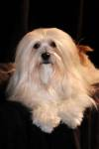 | CH.Yankee Joe Vom Salzetal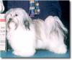 | VDHVKSetacane Martini Mit Zitrone
 |  |  |  | Unbelievable Uljana Vom Salzetal
 |  |  | CHEstrella's Razzle Dazzle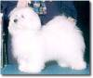 | HSDAA & AKC CHSalemi CharlyROMX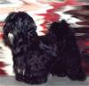
 |  |  |  | Kolmar's Rosie Mi Novia
Beseme's Telling It Like It Is | UKC CHBeseme's Wee ShaggyLuv'RRN | CHLos Feliz Splash Of Mollimar | CHLos Perritos Wee PantaloonsROMX | CHLos Perritos LuigiROM
 |  |  |  | US CHBorgia's Evita Of Romanijo's JoyROMX
 |  |  | CHKolmar's MS QT PI Of Los Feliz | AM. CAN. CH.Voila Clean SweepROM
 |  |  |  | CHKolmar's La Nina Del Milenio
 |  | CH.SandCastle's Heart's DesireRN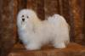 | AKC, UKC, INT CHShaggyluv's BlockbusterNA, NAJ, NJP, RN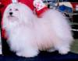 | AKC, ARBA CHShaggyluv's EnergizerNA, NAJ, OA, OAJ, RN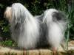
 |  |  |  | AKC, ARBA, HCA CHShaggyluv's Golden GirlNA, NAJ, OA, OAJ, RN, RA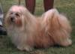
 |  |  | CHShelley's Havana Queen of HeartsROM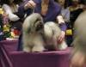 | CHAlderon's Shelley's Jamoacha
 |  |  |  | Destiny's Shelley's Cookies N Creme
 | GCH UKC BISBeseme's Any Dream Will Do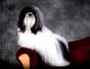 | CHLos Feliz Splash Of Mollimar | CHLos Perritos Wee PantaloonsROMX | CHLos Perritos LuigiROM
 |  |  |  | US CHBorgia's Evita Of Romanijo's JoyROMX
 |  |  | CHKolmar's MS QT PI Of Los Feliz | AM. CAN. CH.Voila Clean SweepROM
 |  |  |  | CHKolmar's La Nina Del Milenio
 |  | GCH CHBeseme's An Affair To Remember | CHShelley's Rickie Ricardo | CHAlderon's Shelley's Jamoacha
 |  |  |  | Destiny's Shelley's Cookies N Creme
 |  |  | CHLiveoak's Southern CharmRN ROM | CH.Yankee Joe Vom Salzetal
 |  |  |  | CHEstrella's Razzle Dazzle

